3D Trash Math
In honor of Earth Day (April 22) students are invited to bring in an empty box, can or container to add to our classroom sculpture. The item your child brings must be in the form of a 3D Shape AND disposable. (This should cost NO money at all.)
As a class, we will vote on the type of sculpture we want to make (house, castle, robot...) Then we will plan and design the sculpture using the 3D shapes we saved from the trash!

What do we mean by 3D Shape?
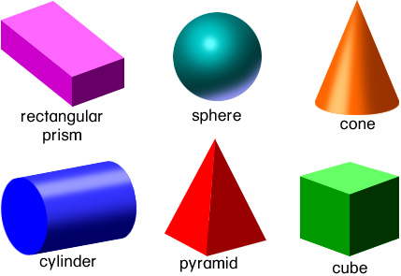

Some examples of 3D shapes the students came up with include:
Cylinders- empty tin can, used-up glue stick, empty hair spray can
Rectangular prism – macaroni and cheese box, cereal box
Cube – cardboard box from candy, food or jewelry
Sphere – wadded up newspaper, foil ball
Cone – party hat, newspaper cone

3D Shapes are DUE Tuesday, April 24.
We will begin planning the sculpture next Wednesday
(when we know what shapes we have available.) Be creative! Have fun!!

